Exercise – 1

**Create a Spring Web Project using Maven**

**Steps to Create a Web Project using Maven:**

1. Go to <https://start.spring.io/> and choose the following options according to our project requirements and system compatibility.

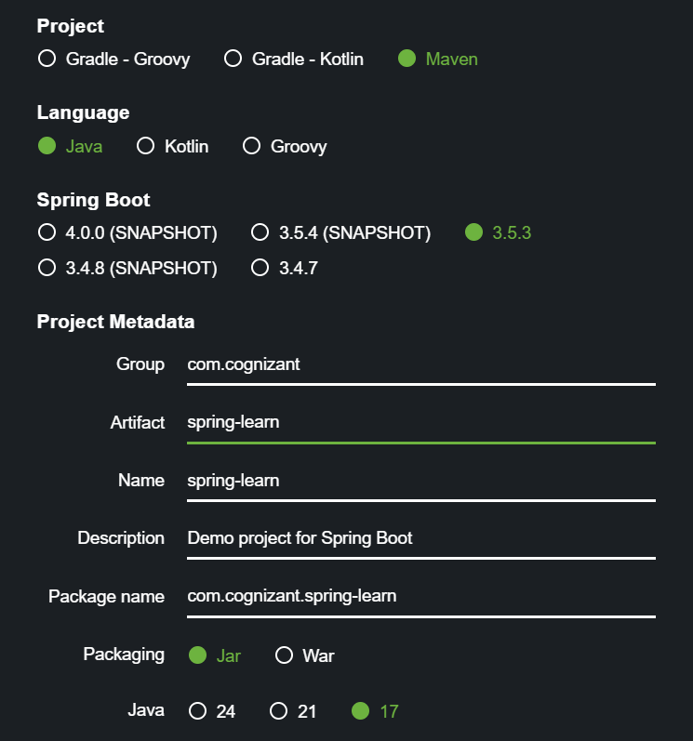

1. Click on “Generate” to generate the zip file for the Web Project
2. Unzip the file downloaded and open it in an IDE.

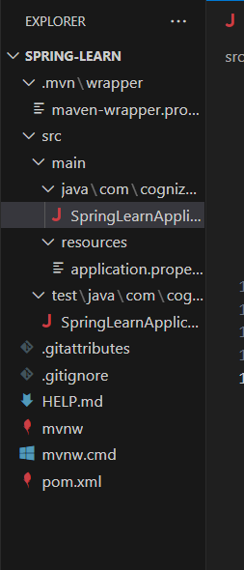

Dependecies (pom.xml)

<?xml version="1.0" encoding="UTF-8"?>

<project xmlns="http://maven.apache.org/POM/4.0.0" xmlns:xsi="http://www.w3.org/2001/XMLSchema-instance"

    xsi:schemaLocation="http://maven.apache.org/POM/4.0.0 https://maven.apache.org/xsd/maven-4.0.0.xsd">

    <modelVersion>4.0.0</modelVersion>

    <parent>

        <groupId>org.springframework.boot</groupId>

        <artifactId>spring-boot-starter-parent</artifactId>

        <version>3.5.3</version>

        <relativePath/> <!-- lookup parent from repository -->

    </parent>

    <groupId>com.cognizant</groupId>

    <artifactId>spring-learn</artifactId>

    <version>0.0.1-SNAPSHOT</version>

    <name>spring-learn</name>

    <description>Demo project for Spring Boot</description>

    <url/>

    <licenses>

        <license/>

    </licenses>

    <developers>

        <developer/>

    </developers>

    <scm>

        <connection/>

        <developerConnection/>

        <tag/>

        <url/>

    </scm>

    <properties>

        <java.version>24</java.version>

    </properties>

    <dependencies>

        <dependency>

            <groupId>org.springframework.boot</groupId>

            <artifactId>spring-boot-starter</artifactId>

        </dependency>

        <dependency>

            <groupId>org.springframework.boot</groupId>

            <artifactId>spring-boot-starter-test</artifactId>

            <scope>test</scope>

        </dependency>

    </dependencies>

    <build>

        <plugins>

            <plugin>

                <groupId>org.springframework.boot</groupId>

                <artifactId>spring-boot-maven-plugin</artifactId>

            </plugin>

        </plugins>

    </build>

</project>